Place inside light squares on browser screen BG so they ideally look like this:  
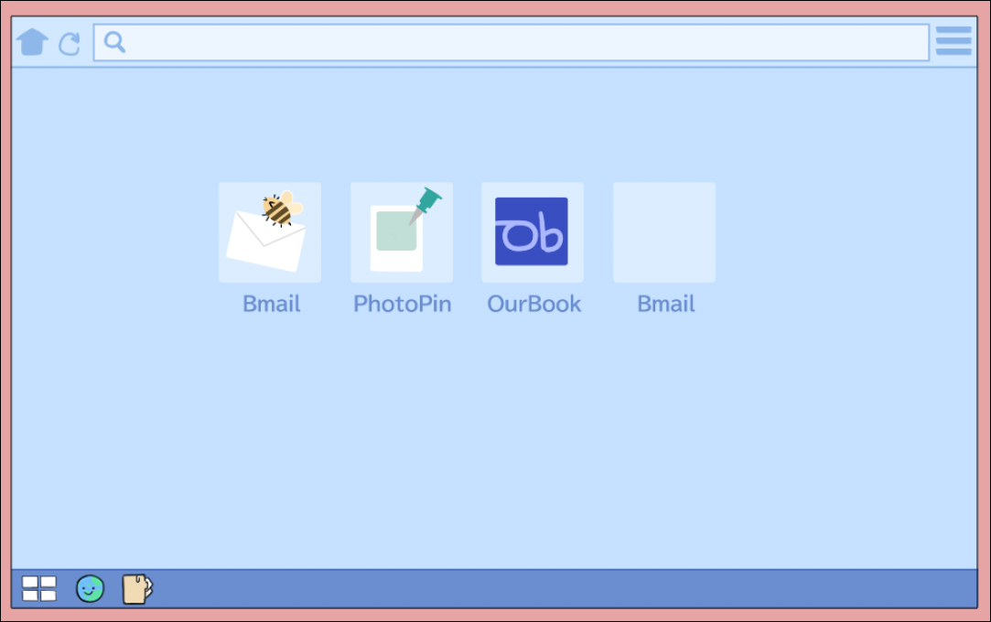

No text – only icons

Has text – includes shotcut text (ie BMAIL for icon 1)

There is a browser bg variation where the shortcuts are included in the texture